SRI.D.N.R.GOVERNMENT DEGREE COLLEGE FOR WOMEN, PALAKOL, W.G.DT
DIGITAL CLASS ROOMS AVAILABLE DURING THE ACADEMIC YEAR 2020-21

4.1.3 Number of classrooms and seminar halls with ICT-enabled facilities such as smart class, LMS, etc.
R.no:5 with smart board and Wi-Fi
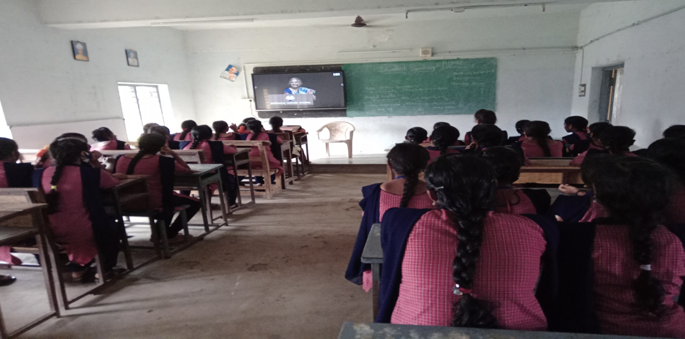
R.no:6 with LCD projector and Wi-Fi
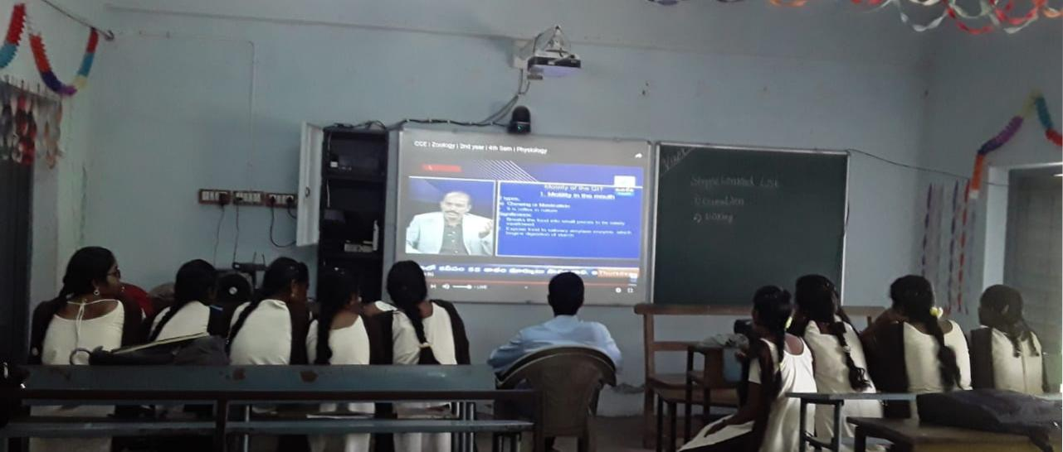
R.no:16 with smart board and Wi-Fi
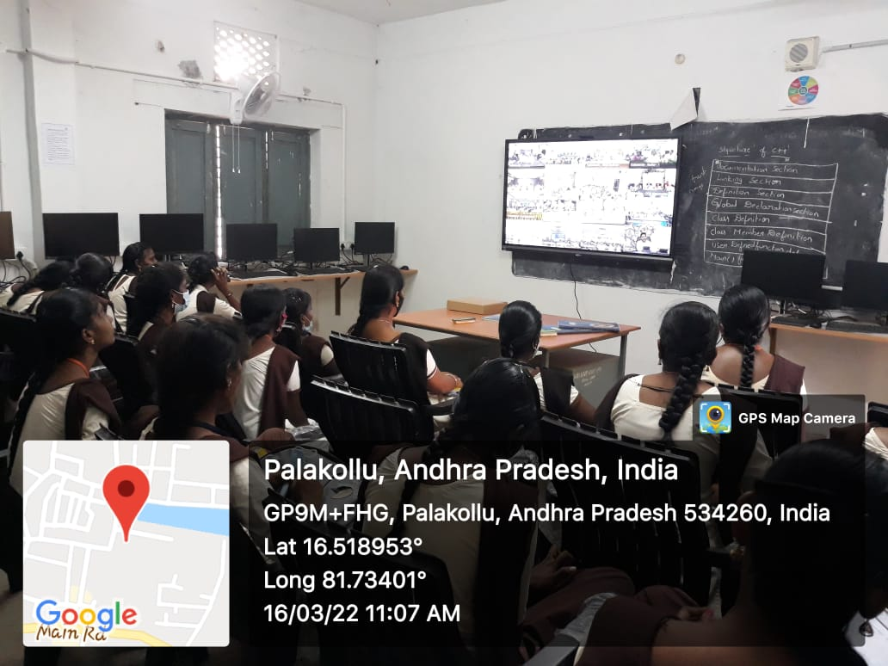

R.no:17 with LCD, Wi-Fi and LAN Facilities
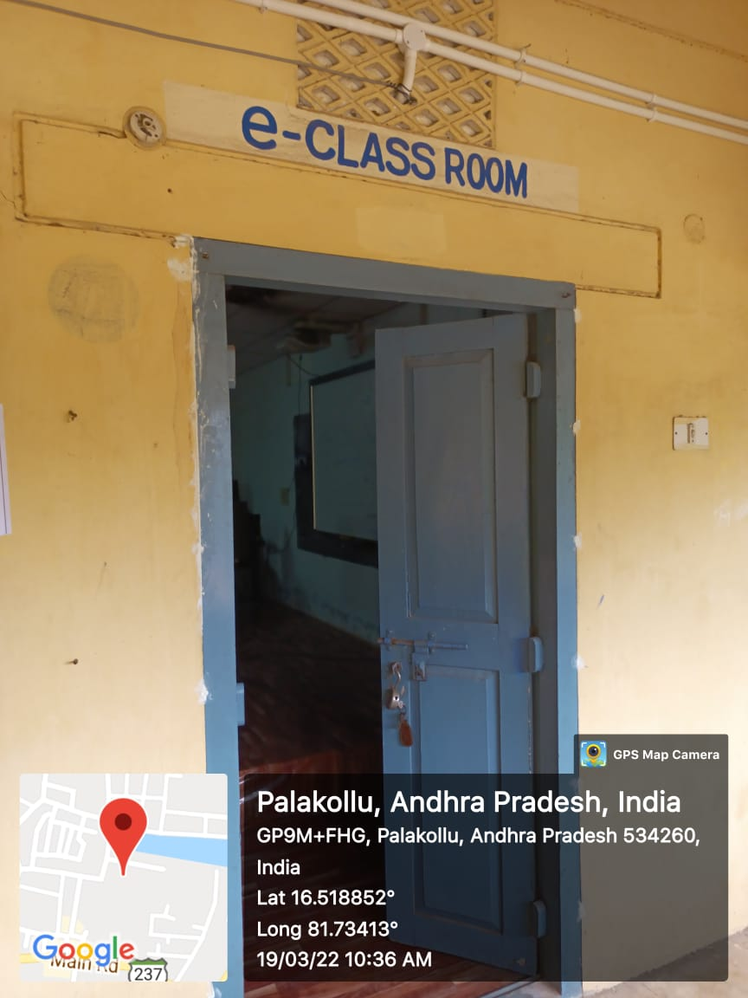

R.no:18 with smart board and Wi-Fi
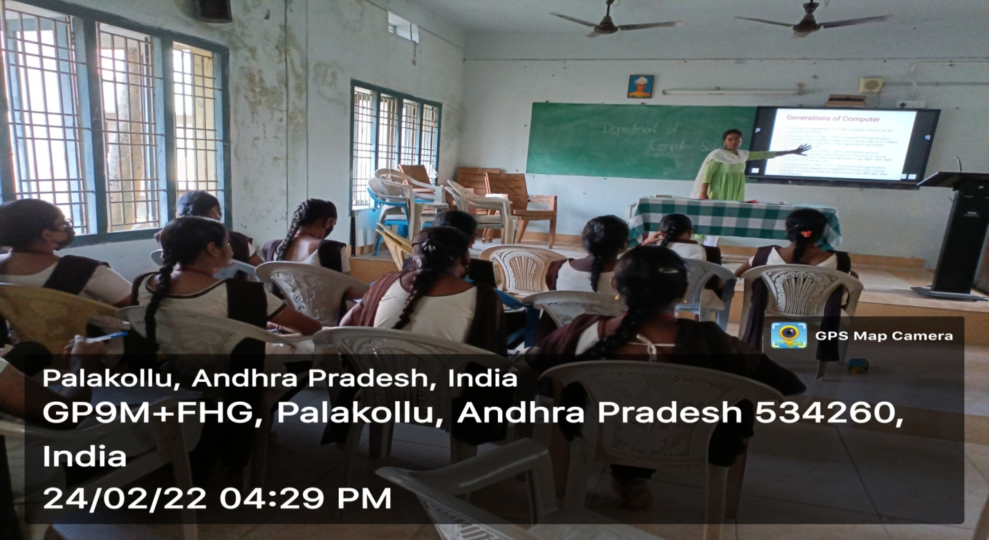

R.no:22 with smart board and Wi-Fi

